

Module : CS4001 Programming Course work 2023-2024

Student Name : Ugochukwu Chikwendu

Student ID: 20040167

Weighting: 60% of module mark
Deadline: 1st of May 2024

Module Leader: Dr Sandra Fernando

PLAGIARISM
You are reminded that there exist regulations concerning plagiarism. Extracts from these regulations are printed below. Please sign below to say that you have read and understand these extracts:

Signature: ugo Date: july,2024

This header sheet should be attached to the work you submit. No work will be accepted without it.

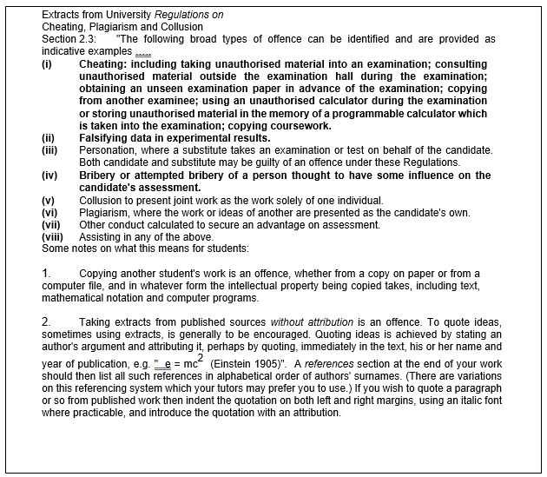

Introduction 4
Methods 4
Gadget.java 4
Mobile.java Methods 5
MP3.java Methods 5
Pseudocode for Button-Handling Methods 5
Getting the Display Number from the GUI 5
Adding a Mobile 5
Adding an MP3 6
Displaying All Gadgets in the ArrayList 6
Making a Call 6
Downloading Music 6
Textboxes, Input Check with Try/Catch 6
Buttons And Action Performed Methods 9
Command Prompt Testing 10
Error Detection & Correction 10
Conclusion 11
REFLECTION. 11
References 12
Appendix 13
Gadget: 13
Mobile: 13
MP3: 14
GadgetShop 15

Introduction
Java programming language is an object-oriented language that uses bytecode instructions carried out by a stack-based virtual engine. It is one of the most widely used programming languages in enterprise development (Oracle 2023). One of the many benefits of Java bytecode-based architecture over assembly language, is that code written once can run on several platforms, provided each platform has a virtual machine implementation.
The project is a Java programme designed to manage a gadget shop. It has a graphical user interface (GUI) that allows users to add MP3 players and cell phones to the shop's inventory. There are multiple classes in the application: Gadget, Mobile, MP3, and GadgetShop. While Mobile and MP3 are subclasses of devices that represent certain gadgets with extra features, the Gadget class represents a generic device with qualities like model, price, weight, and size. Using Swing components, the GadgetShop class implements the GUI and lets users add, view, and manage gadgets. It also lets users download music to MP3 players and make phone calls from mobile devices. Try-catch blocks are used in the GUI's input validation to gracefully manage errors and guarantee its usability.

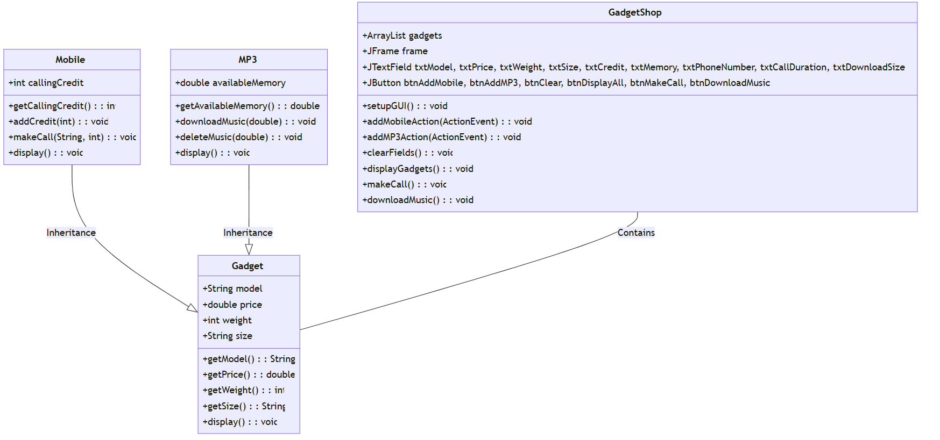
Figure 1: Class Diagram

Methods

Gadget.java
Constructor: Initializes a Gadget object with model, price, weight, and size properties.
getModel(): Returns the model of the gadget.
getPrice(): Returns the price of the gadget.
getWeight(): Returns the weight of the gadget.
getSize(): Returns the size of the gadget.
display(): Prints the details of the gadget including model, price, weight, and size.

Mobile.java Methods
Constructor: Initializes a Mobile object by calling the superclass constructor and sets the calling credit.
getCallingCredit(): Returns the amount of calling credit available on the mobile.
addCredit(int credit): Adds a specified amount of calling credit if it is positive; otherwise, it prints an error message.
makeCall(String phoneNumber, int duration): Deducts the specified duration from the calling credit to make a call if enough credit is available; otherwise, it prints an error message indicating insufficient credit.
display(): Displays the details of the mobile including inherited gadget properties and the available calling credit.

MP3.java Methods
Constructor: Initializes an MP3 object by calling the superclass constructor and sets the available memory.
getAvailableMemory(): Returns the available memory on the MP3 player.
downloadMusic(double size): Deducts the specified size from the available memory for downloading music if enough memory is available; otherwise, prints an error message indicating insufficient memory.
deleteMusic(double size): Adds the specified size back to the available memory, simulating the deletion of music.
display(): Displays the details of the MP3 player including inherited gadget properties and the available memory.

Pseudocode for Button-Handling Methods

Getting the Display Number from the GUI
function getDisplayNumber():
number = read text from txtModel text field
if number is valid:
return number
else:
print "Invalid input"
return null

Adding a Mobile
function addMobile():
model = get text from txtModel
price = convert txtPrice to double
weight = convert txtWeight to integer
size = get text from txtSize
credit = convert txtCredit to integer
mobile = new Mobile(model, price, weight, size, credit)
add mobile to gadgets list
display "Mobile added"

Adding an MP3
function addMP3():
model = get text from txtModel
price = convert txtPrice to double
weight = convert txtWeight to integer
size = get text from txtSize
memory = convert txtMemory to double
mp3 = new MP3(model, price, weight, size, memory)
add mp3 to gadgets list
display "MP3 added"

Displaying All Gadgets in the ArrayList
function displayGadgets():
for each gadget in gadgets list:
gadget.display()

Making a Call
function makeCall():
phoneNumber = get text from txtPhoneNumber
duration = convert txtCallDuration to integer
mobile = find mobile with model number (getDisplayNumber())
if mobile is not null:
mobile.makeCall(phoneNumber, duration)
else:
display "Mobile not found"

Downloading Music
function downloadMusic():
size = convert txtDownloadSize to double
mp3 = find MP3 with model number (getDisplayNumber())
if mp3 is not null:
mp3. downloadMusic(size)
else:display "MP3 not found"

Textboxes, Input Check with Try/Catch
Try-catch is a programming technique used to encapsulate code blocks that have a chance of error, like processing textbox user input into numeric data types (Merritt, 2001). The application tries to run the code normally within the try block. The catch block catches exceptions that arise during execution, such as a NumberFormatException brought on by improper input. In this case, it manages the exception by informing the user through the proper error messages that the input is invalid and requesting that they take corrective action. Try-catch blocks are used to keep the application robust by preventing crashes and to provide a more seamless user experience by gently managing user input mistakes (Mehrabi et al., 2018).
The following code below contains two methods, addMobileAction, and addMP3Action, that handle actions caused by GUI events such as button clicks. Every method has an identical structure, with a try block holding the core logic. These blocks employ the helper methods parseInt and parseDouble to parse user input that is obtained from text fields into the proper data types, like integers or doubles. Try-catch blocks wrap these assistance methods, guaranteeing that any NumberFormatExceptions are caught and handled politely. An error message mentioning the field where the issue occurred is displayed to the user via a JOptionPane if an exception during parsing indicates improper input. In addition, if necessary, the exception is thrown again to spread it wider.
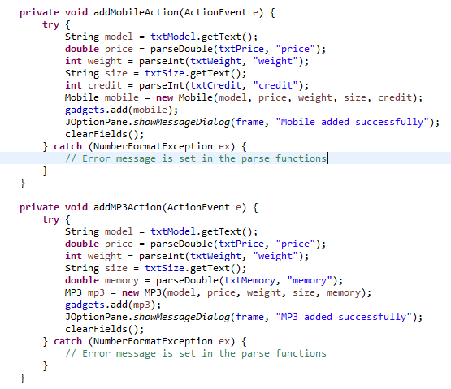
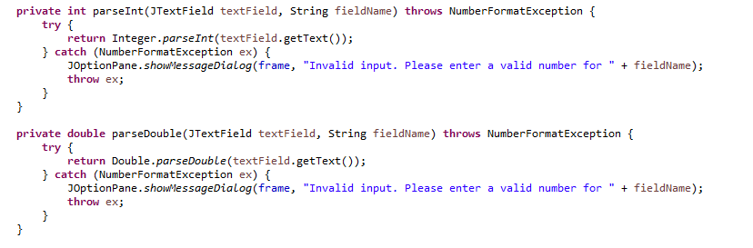
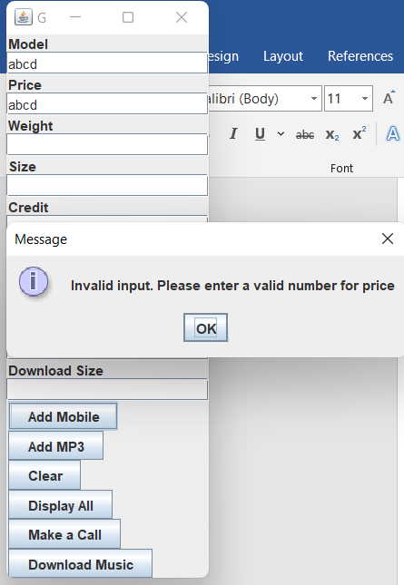

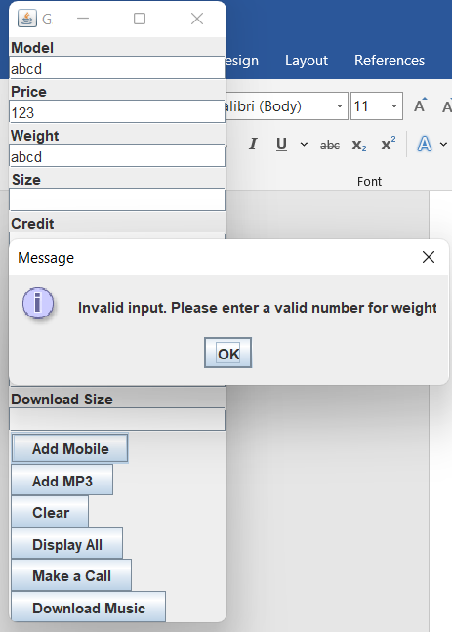
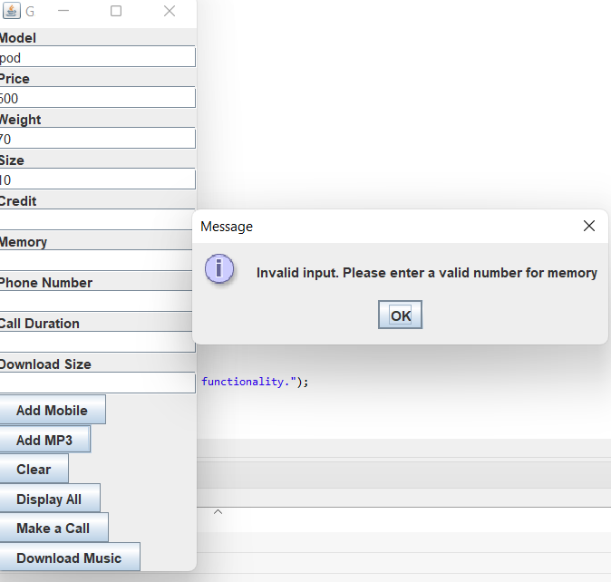

Buttons And Action Performed Methods
The term "graphical user interface" (GUI) describes the visual interface, which enables users to interact with the programme through the use of graphical components including buttons, text fields, and dialogues (Etheridge, 2009). Users can input data, initiate operations, and receive feedback from the application in an easy-to-use manner thanks to the GUI.
The GUI application’s displays buttons for several functions, such as "Add MP3," "Add Mobile," "Display All," "Make a Call," and "Download Music." Within the gadget shop programme, each button denotes a distinct action that the user can take. When a user clicks the "Add MP3" or "Add Mobile" buttons, text fields containing pertinent information such as the MP3 player's model, price, weight, size, memory, or calling credit are displayed. This adds the new MP3 player or mobile phone to the shop's inventory, respectively. By selecting the "Display All" button, customers may see every device that is presently listed in the inventory, giving them a thorough overview of everything that is accessible. Similarly, the buttons labelled "Make a Call" and "Download Music" enable activities exclusive to MP3 players and mobile phones, respectively. By clicking these buttons, customers are prompted to enter further information, including the phone number and duration of the call when placing a call or the download size while downloading music.
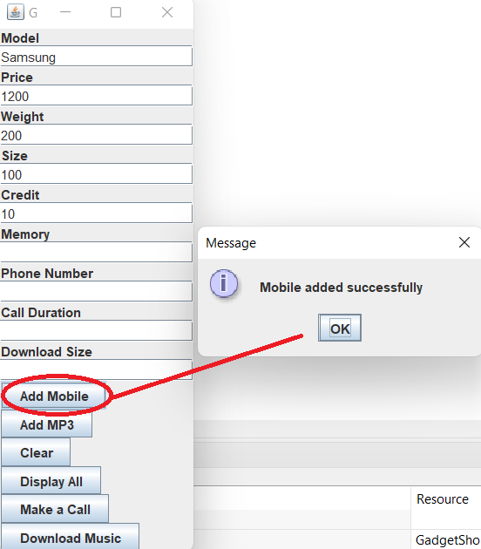
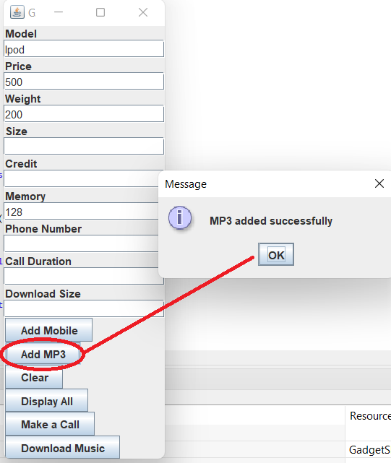
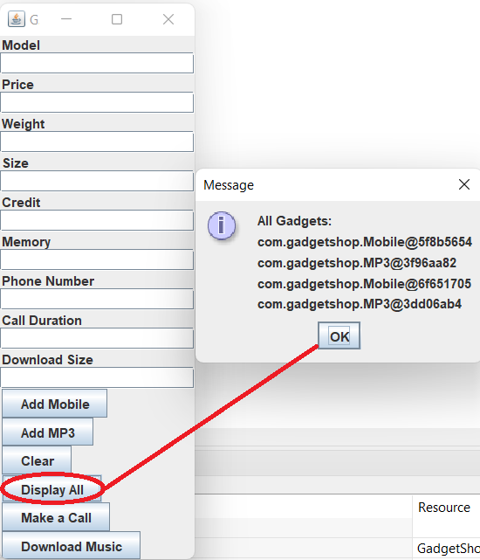
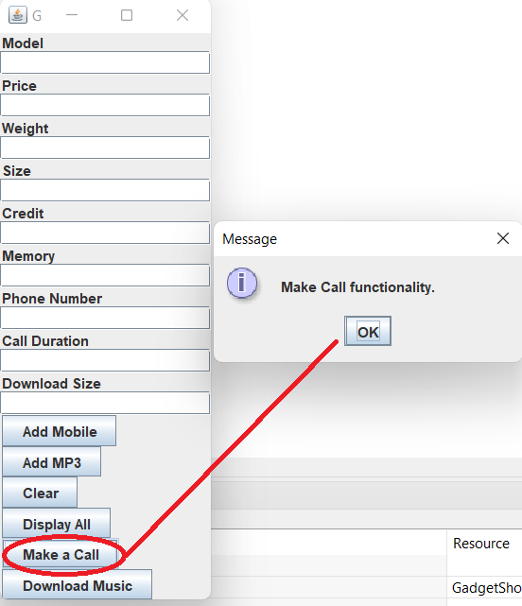
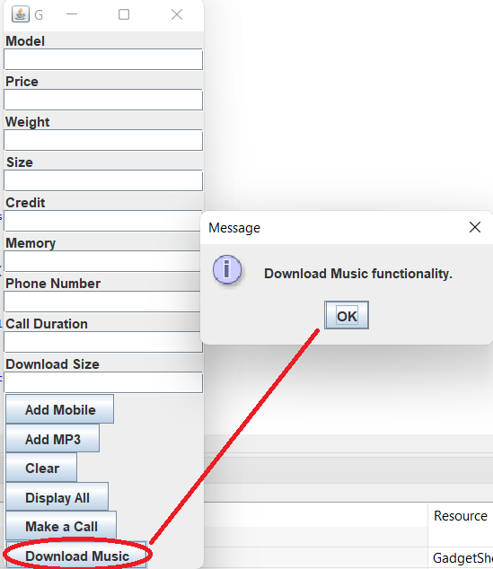

Command Prompt Testing
Command prompt testing is a software development process that runs the application directly from the command line interface (CLI) rather than a graphical user interface (GUI) or integrated development environment (IDE) (Bolepally, 2023). I have used the command java -cp. com.gadgetshop.GadgetShop to test the programme at the command prompt. This command-line testing confirms the application's compatibility with various platforms and verifies its functioning in a command-line environment. It also makes sure the application can be successfully compiled and executed outside of an integrated development environment (IDE). This command starts the Java Virtual Machine (JVM) and tells it to run the GadgetShop main class, which is part of the com.gadgetshop package. The classpath is specified by the -cp. flag, which indicates that in order to find the classes required for execution, the current directory (.) should be included in the classpath. When the programme runs, the gadget shop application is initialised and the graphical user interface (GUI) is displayed for user interaction.
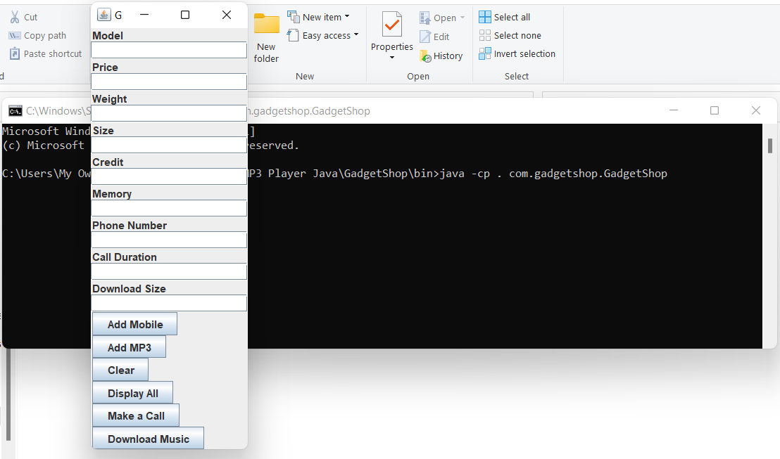

Error Detection & Correction
In particular, procedures that are in charge of passing user input have error detection and correction mechanisms incorporated. The parseInt and parseDouble methods, for example, use try blocks to encapsulate the conversion of text field input into integer and double data types, respectively. These blocks try to convert the input and catch any NumberFormatExceptions that might occur, which would indicate incorrect input. When an exception is caught, the code uses JOptionPane to display an error message to the user, identifying the precise field (e.g., price, weight, or memory) that contained the mistake. Users are able to effectively correct input errors because to this instant feedback. In addition, the clearFields function offers a remedial measure by restoring all text fields to their initial values, allowing users to restart after resolving input issues. Furthermore, helpful error messages facilitate a better user experience by helping users recognise and fix their faults (Hristova et al., 2003).

Conclusion

In summary, the gadget shop project demonstrates a successful implementation of a Java application with a graphical user interface (GUI) for inventory management and user interaction. Key accomplishments during the development process include creating classes to represent devices such as MP3 players and cell phones, using Swing components to build an intuitive graphical user interface, and integrating functions to add, display, and perform actions on devices. Notably, error detection and correction techniques were implemented to enhance user experience and resilience. However, the gadget store project's reliance on the Swing library for creating the GUI is one of its drawbacks. While Swing facilitates the development of cross-platform Java GUI applications, its user interface design may not be as visually appealing or up-to-date compared to more recent technologies like web-based frameworks or JavaFX. This might make the application appear less intuitive to users accustomed to modern UI designs, potentially impacting their overall satisfaction and usage. Despite this, the project not only meets the required standards but also demonstrates effective programming techniques such as modularity, error management, and user interface design.

REFLECTION.
As a newbie in programming, it was incredibly challenging to comprehend java from the onset in the classroom lecturing. But as time proceeds, and having gone through this coursework, i am feeling a lot more confident in learning programming moving forward.
The coursework has opened my mind to thinking more as a programmer. Although i am aware there are a great deal of improvements to be made.
I am grateful to all the tutors for their encouragement and patience as I am extremely optimistic about the progress I can make with their brilliant support.

References

Mehrabi, M., Giacaman, N. and Sinnen, O., 2018, May. Unobtrusive Asynchronous Exception Handling with Standard Java Try/Catch Blocks. In 2018 IEEE International Parallel and Distributed Processing Symposium (IPDPS) (pp. 855-864). IEEE.
Hristova, M., Misra, A., Rutter, M. and Mercuri, R., 2003. Identifying and correcting Java programming errors for introductory computer science students. ACM Sigcse Bulletin, 35(1), pp.153-156.

Bolepally, A., 2023. NAND Command Line Interface Bench test program (Doctoral dissertation, California State University, Sacramento).

Oracle.com. (2023). Java Software. [online] Available at: https://www.oracle.com/java [Accessed, 25 April, 2024].

Etheridge, D., 2009. Java: Graphical User Interfaces. BookBoon.

Merritt, S.M., 2001. Exception handling in java: the try/catch/finally statement.

Oracle Help Center. (n.d.). JDK 22 Documentation. [online] Available at: https://docs.oracle.com/en/java/javase/22/ [Accessed, 25 April, 2024].

Appendix

Gadget:
package com.gadgetshop;
public class Gadget {
private String model;
private double price;
private int weight;
private String size;
public Gadget(String model, double price, int weight, String size) {
this.model = model;
this.price = price;
this.weight = weight;
this.size = size;
}
public String getModel() {
return model;
}
public double getPrice() {
return price;
}
public int getWeight() {
return weight;
}
public String getSize() {
return size;
}
public void display() {
System.out.println("Model: " + model);
System.out.println("Price: £" + price);
System.out.println("Weight: " + weight + "g");
System.out.println("Size: " + size);
}
}

Mobile:
package com.gadgetshop;
public class Mobile extends Gadget {
private int callingCredit;
public Mobile(String model, double price, int weight, String size, int callingCredit) {
super(model, price, weight, size);
this.callingCredit = callingCredit;
}
public int getCallingCredit() {
return callingCredit;
}
public void addCredit(int credit) {
if (credit > 0) {
callingCredit += credit;
System.out.println("Added " + credit + " minutes of credit.");
} else {
System.out.println("Please enter a positive amount of credit.");
}
}
public void makeCall(String phoneNumber, int duration) {
if (duration <= callingCredit) {
callingCredit -= duration;
System.out.println("Call made to: " + phoneNumber + " for " + duration + " minutes.");
} else {
System.out.println("Insufficient credit to make the call.");
}
}
@Override
public void display() {
super.display();
System.out.println("Calling Credit: " + callingCredit + " minutes");
}
}

MP3:
package com.gadgetshop;
public class MP3 extends Gadget {
private double availableMemory;
public MP3(String model, double price, int weight, String size, double availableMemory) {
super(model, price, weight, size);
this.availableMemory = availableMemory;
}
public double getAvailableMemory() {
return availableMemory;
}
public void downloadMusic(double size) {
if (size <= availableMemory) {
availableMemory -= size;
System.out.println("Downloaded " + size + "MB of music.");
} else {
System.out.println("Insufficient memory to download music.");
}
}
public void deleteMusic(double size) {
availableMemory += size;
System.out.println("Deleted " + size + "MB of music, freeing up space.");
}
@Override
public void display() {
super.display();
System.out.println("Available Memory: " + availableMemory + "MB");
}
}
GadgetShop:
package com.gadgetshop;
import javax.swing.*;
import java.awt.*;
import java.awt.event.*;
import java.util.ArrayList;
public class GadgetShop {
private ArrayList<Gadget> gadgets;
private JFrame frame;
private JPanel panel;
private JTextField txtModel;
private JTextField txtPrice;
private JTextField txtWeight;
private JTextField txtSize;
private JTextField txtCredit;
private JTextField txtMemory;
private JTextField txtPhoneNumber;
private JTextField txtCallDuration;
private JTextField txtDownloadSize;
private JButton btnAddMobile;
private JButton btnAddMP3;
private JButton btnClear;
private JButton btnDisplayAll;
private JButton btnMakeCall;
private JButton btnDownloadMusic;
public GadgetShop() {
gadgets = new ArrayList<>();
setupGUI();
}
private void setupGUI() {
frame = new JFrame("Gadget Shop");
panel = new JPanel();
panel.setLayout(new BoxLayout(panel, BoxLayout.Y_AXIS));
txtModel = new JTextField(10);
txtPrice = new JTextField(10);
txtWeight = new JTextField(10);
txtSize = new JTextField(10);
txtCredit = new JTextField(10);
txtMemory = new JTextField(10);
txtPhoneNumber = new JTextField(10);
txtCallDuration = new JTextField(10);
txtDownloadSize = new JTextField(10);
btnAddMobile = new JButton("Add Mobile");
btnAddMP3 = new JButton("Add MP3");
btnClear = new JButton("Clear");
btnDisplayAll = new JButton("Display All");
btnMakeCall = new JButton("Make a Call");
btnDownloadMusic = new JButton("Download Music");
// Adding action listeners to the buttons
btnAddMobile.addActionListener(this::addMobileAction);
btnAddMP3.addActionListener(this::addMP3Action);
btnClear.addActionListener(e -> clearFields());
btnDisplayAll.addActionListener(e -> displayGadgets());
btnMakeCall.addActionListener(e -> makeCall());
btnDownloadMusic.addActionListener(e -> downloadMusic());
panel.add(new JLabel("Model"));
panel.add(txtModel);
panel.add(new JLabel("Price"));
panel.add(txtPrice);
panel.add(new JLabel("Weight"));
panel.add(txtWeight);
panel.add(new JLabel("Size"));
panel.add(txtSize);
panel.add(new JLabel("Credit"));
panel.add(txtCredit);
panel.add(new JLabel("Memory"));
panel.add(txtMemory);
panel.add(new JLabel("Phone Number"));
panel.add(txtPhoneNumber);
panel.add(new JLabel("Call Duration"));
panel.add(txtCallDuration);
panel.add(new JLabel("Download Size"));
panel.add(txtDownloadSize);
panel.add(btnAddMobile);
panel.add(btnAddMP3);
panel.add(btnClear);
panel.add(btnDisplayAll);
panel.add(btnMakeCall);
panel.add(btnDownloadMusic);
frame.add(panel);
frame.pack();
frame.setVisible(true);
frame.setDefaultCloseOperation(JFrame.EXIT_ON_CLOSE);
}
private void addMobileAction(ActionEvent e) {
try {
String model = txtModel.getText();
double price = parseDouble(txtPrice, "price");
int weight = parseInt(txtWeight, "weight");
String size = txtSize.getText();
int credit = parseInt(txtCredit, "credit");
Mobile mobile = new Mobile(model, price, weight, size, credit);
gadgets.add(mobile);
JOptionPane.showMessageDialog(frame, "Mobile added successfully");
clearFields();
} catch (NumberFormatException ex) {
// Error message is set in the parse functions
}
}
private void addMP3Action(ActionEvent e) {
try {
String model = txtModel.getText();
double price = parseDouble(txtPrice, "price");
int weight = parseInt(txtWeight, "weight");
String size = txtSize.getText();
double memory = parseDouble(txtMemory, "memory");
MP3 mp3 = new MP3(model, price, weight, size, memory);
gadgets.add(mp3);
JOptionPane.showMessageDialog(frame, "MP3 added successfully");
clearFields();
} catch (NumberFormatException ex) {
// Error message is set in the parse functions
}
}
private int parseInt(JTextField textField, String fieldName) throws NumberFormatException {
try {
return Integer.parseInt(textField.getText());
} catch (NumberFormatException ex) {
JOptionPane.showMessageDialog(frame, "Invalid input. Please enter a valid number for " + fieldName);
throw ex;
}
}
private double parseDouble(JTextField textField, String fieldName) throws NumberFormatException {
try {
return Double.parseDouble(textField.getText());
} catch (NumberFormatException ex) {
JOptionPane.showMessageDialog(frame, "Invalid input. Please enter a valid number for " + fieldName);
throw ex;
}
}
private void clearFields() {
txtModel.setText("");
txtPrice.setText("");
txtWeight.setText("");
txtSize.setText("");
txtCredit.setText("");
txtMemory.setText("");
txtPhoneNumber.setText("");
txtCallDuration.setText("");
txtDownloadSize.setText("");
}
private void displayGadgets() {
StringBuilder displayText = new StringBuilder("All Gadgets:\n");
for (Gadget gadget : gadgets) {
displayText.append(gadget.toString()).append("\n");
}
JOptionPane.showMessageDialog(frame, displayText.toString());
}
private void makeCall() {
JOptionPane.showMessageDialog(frame, "Make Call functionality.");
}
private void downloadMusic() {
JOptionPane.showMessageDialog(frame, "Download Music functionality.");
}
public static void main(String[] args) {
new GadgetShop();
}
}

